A1150- AM,S-Peru-Chancay-Textile Figurine-Female-1000-1470 CE

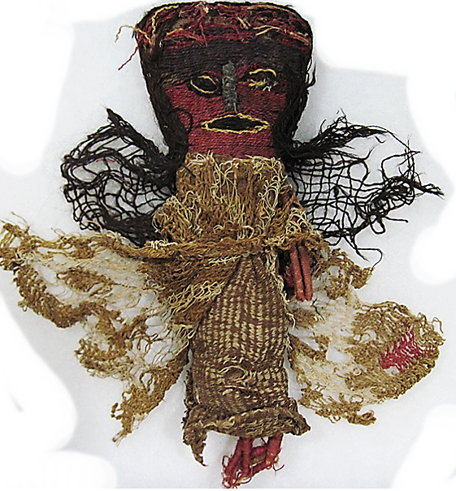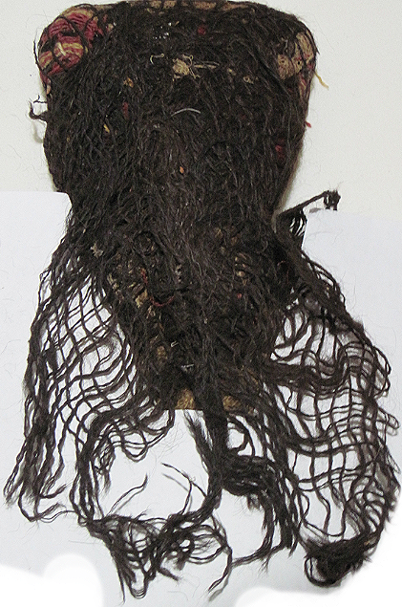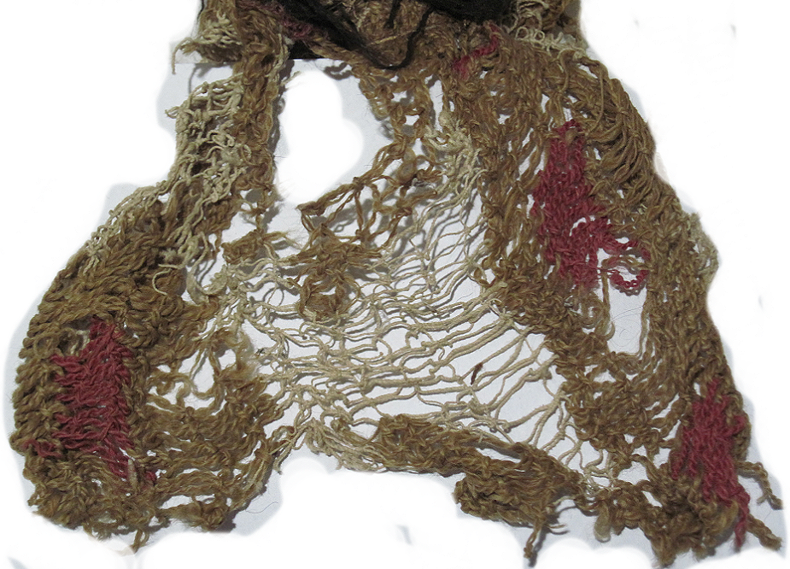

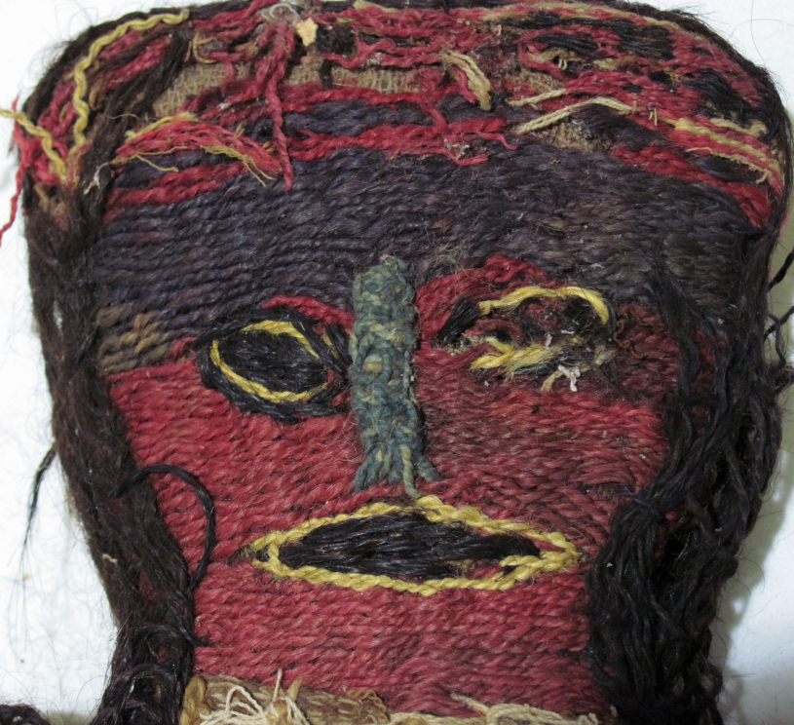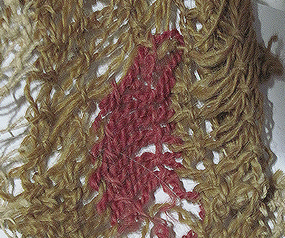

Figs 1-5. Peru-Chancay-Textile Figurine-Female-1000-1470 CE

**Case no.: Textiles**

**Accession Number:** A1150

**Formal Label:** Chancay-Textile Figurine-Female-1000-1470 CE

**Display Description:**

The Chancay civilization that produced this artifact developed between the Chancay, Chillon, Rimac and Lurin Valleys, on the central coast of Peru between 1200 and 1470 CE. Its center was located 80 km. north of Lima. The territory occupied a coastal region interspersed with rivers flowing down fertile valleys, which provided the opportunity for agricultural development, population expansion and craft specialists such as ceramicists and weavers.

These textile figurines offer a rare chance to closely examine the exquisite threads, fabrics and loom techniques from one of the world's most sophisticated textile cultures (Lehman 2005). This Chancay polychromatic “burial ‘doll” is not a “doll” in the commonly understood sense that it is a “toy.” Rather, it is a “textile figurine,” which is how we will refer to it here. A “textile figurine” is similar to a “ceramic figurine,” in that it represents a gendered anthropomorph (a human, a deity or an avatar) that was placed in tombs to provide the deceased with companionship and guidance on their journey to the hereafter. It is believed that they were meant to be guardian companions for the departing soul. Some textile figurines seem to evoke specific individuals who were dear to the deceased. It may be that this textile figurine performed such a service. The tapestry face has tones of purple, blue white and black threads, which is unusual and may have iconographic significance as a deceased ancestor or as a guardian deity, since most faces are done in primary colors.

Indigo, a yellow-brown plant dye, and red, possibly from a species of *relbunium, achiote (Bixa orellana*), or from cochineal. Cochineal has been found in south-coast Nazca textiles (ca 200 BCE–AD/CE 200) and later eleventh-century textiles of the north coast. It was widely use during the Inca period.

Chancay culture’s textile art was partly influenced from the Paracas culture (800 BCE-200 CE), which is reflected in the fabrics in which the dead were clothed. For instance, the dress of this figurine has a vertically striped design that is similar to many Paracas textiles.

This Chancay textile figurine has a unique sprang-woven over-skirt and shawl. Sprang weaving is one of the oldest textile techniques, which is found in Peru as early as 700 BCE. This unusual loom technique is a very complex version of the cat's cradle. The fabric is created entirely from warp threads without any introduction of weft. The warp threads are stretched between two bars and the fabric is formed as the side by side warp threads are crossed or twisted.

Textile production was prolific and preservative in the dry, sterile air of the central coastal valleys of Peru, which is why this particular artifact has survived 1000 years.

**LC Classification:** F 3429.1 .C47

**Date or Time Horizon:** 1100 AD/CE

**Geographical Area:** Pisquillo Chico, Chancay, Lima, Perú

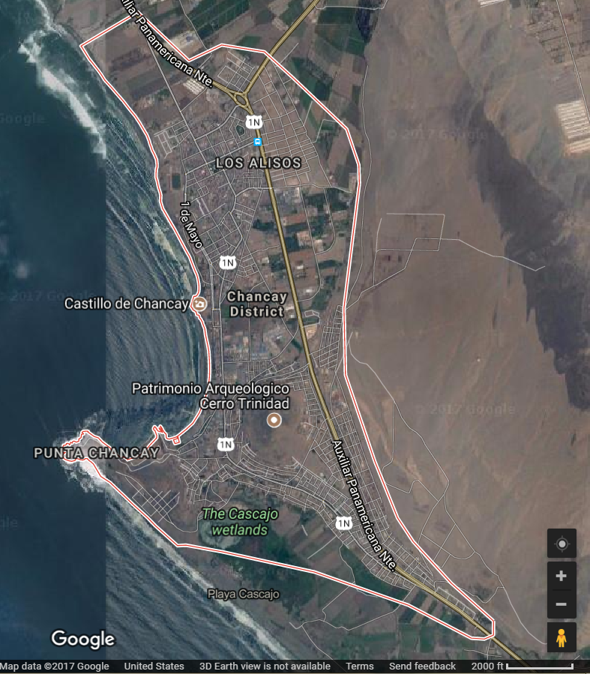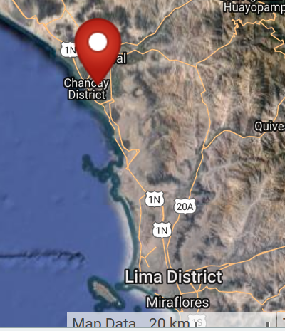

**Fig. 6. Map.** Pisquillo Chico, Chancay, Lima, Perú

**Fig. 7. Map.** Chancay Culture Area, After Google.com.

**GPS coordinates:** 11º34'6.61" S 77º14'13.9" W

**Cultural Affiliation:** Chancay

**Media:** alpaca wool dyed yellow, black and red; cotton dyed blue and cream

**Dimensions:** H 25.4 by 10.16 cm, 10 by 4 in

**Weight: .5 lb**

**Condition: original**

**Provenance:** acquired in Pisquillo Chico, Chancay, Lima, Perú, 1960.

**Discussion:**

Sprang weaving creates a mirrored symmetry; as each set of twists are formed, a corresponding twist is made in the opposite direction. As the twisted fabric forms at one end of the threads, the weaver pushes the mirrored twist up to the top of the cloth. When the twists meet in the middle, the center is secured either by twinning an independent thread through it or knotting it together. Control of the center area is critical to prevent the structure from unravelling. Since most sprang has too many fibers to manage by hand, rods or sticks are used to maintain the fiber positions. Decorative patterns can be introduced by regular variations in the fiber crossings. As crossings accumulate the material needs to be flattened. The thread was spun with a low whorl spindle from very fine cotton. A single thread has a very high twist that collapses into the open spaces of sprang, giving it even more texture and complexity (Evans 1995). Sprang produces very strong open work that is extremely elastic.

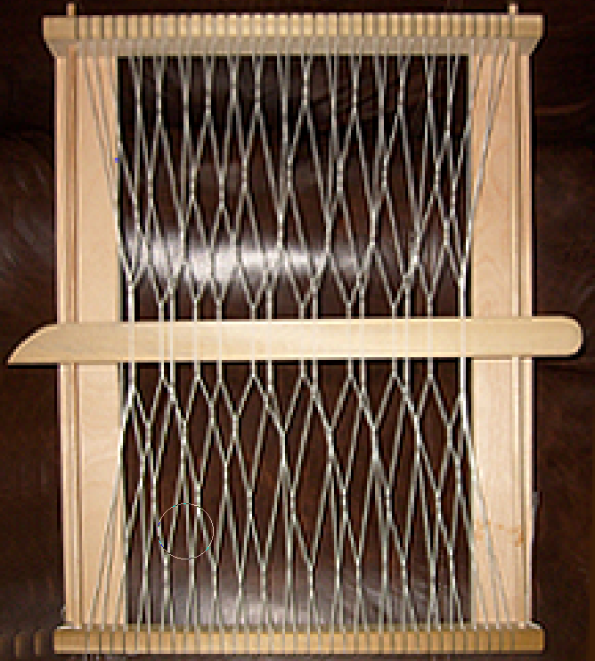

Fig. 8. Sprang Loom by Dufrova. Https.//commons.wikimedia.org/w index.php?curid=4776387

In this female textile figurine intricate, delicate head and body gauzes have been worked into geometric motifs similar to those in tapestries. Gauzes were used for religious purposes, such as for covering the head of the dead in the form of a headdresses. According to Chancay beliefs, the threads on these fabrics had to be spun in the form of an "S" in an anticlockwise direction. This thread, which had a magical character, was called *lloque* and, according to legend, the mortuary garments were infused with supernatural powers and served as protection in the afterlife. Feathers were inserted into a main thread which was then sewn onto the fabric. The feathers thus incorporated the avian ability to carry the person through the firmament to the hereafter. Diagonal, stepped patterns within the textile design were used to define facial features, such as the black mouth framed in yellow and the eyes framed in black and yellow. The diagonal stepped patterns may have also had magical powers as their stepped patterns emulated the stepped patterns of Chancay pyramids.

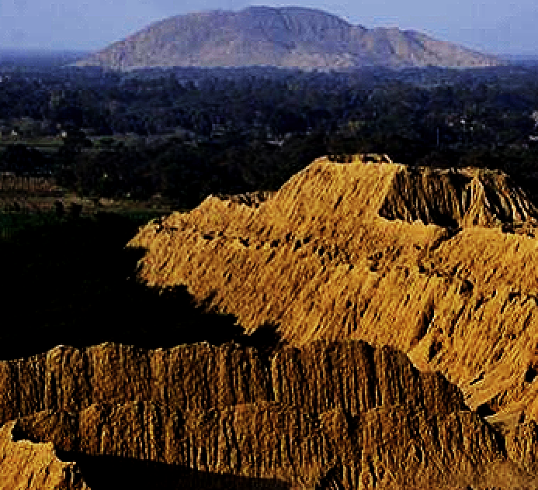

Fig. 9. The archaeological complex of Huaca Rajada is located on the north coast of Peru, in the department of Lambayeque, and is the place where the Tomb of the Lord of Sipan was found. From https://cde.peru.com/ima/0/1/1/5/6/1156236/924x530/turismo-lambayeque-huaca-rajada.jpg

**References:**

Banco de Crédito del Perú. 1982. *Culturas precolombinas: Chanc*ay. Lima, Perú: Banco de Crédito del Perú.

de Lavalle de Cárdenas, Rosario and José Antonio de Lavalle. 1999.  [*Tejidos milenarios del Perú = Ancient Peruvian textiles*](http://www.worldcat.org/title/tejidos-milenarios-del-peru-ancient-peruvian-textiles/oclc/833836524&referer=brief_results). S.l. Integra AFP.

Evans, A.F., 1995. *Representations of duality in a Chancay knotted weft wrapping headcloth in the collection of the Michael C. Carlos Museum* (Doctoral dissertation, Emory University).

Feltham, Jane. 1996. “Chancay.” In Jane Turner, ed., *The Dictionary of Art*, London: MacMillan.

Hodnett, M. K. 1999. *Pre-Columbian dolls in the Amano Museum = Muñecos precolombinos en el Museo Amano*. Lima, Perú: Museo Amano.

Lehman, H. J., 2005. Textiles of the Chimú and Chancay cultures of coastal Peru woven during the Late Intermediate Period: A comparison of processes and techniques. M.A. University of Montana.